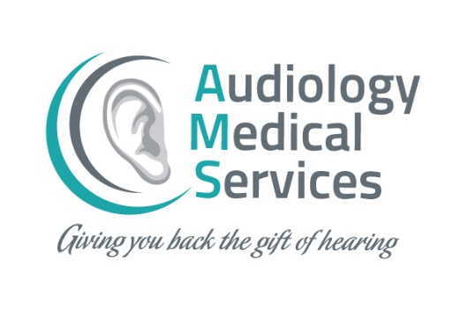

CHRISTMAS COLOURING COMPETITION TERMS & CONDITIONS
- This competition is open to children 12 years of age and under living in the Republic of Ireland.
- Entry into the competition can only be achieved by one of the methods listed below:
  - Post a completed entry to Audiology Medical Services, The Maltings, Main Street, Carrigaline, Cork.
  - Post an image of a completed entry to our Facebook page, making sure to tag us in the post - @AudiologyMedicalServicesIreland
  - Email a photo of a completed entry to hello@audiologymedicalservices.ie
- The competition closes on Friday, 10th December 2021 at 5.00pm. Any entries received after this date will not be included in the competition.
- All entries must have the entry form completed in full and be signed by a parent or legal guardian to be included in the competition.
- A judging panel, chosen at the discretion of Audiology Medical Services, will select the winning entries from three categories: (i) Under 6 years old (ii) 7-9 years old (iii) 10-12 years old with the prize of a €100 shopping voucher for the winner.
- All entrants agree to permit their entries to be displayed in the Audiology Medical Services head office in Carrigaline, County Cork.
- All entrants agree to permit copies of their entries to be used by Audiology Medical Services in print and online formats for promotional purposes.
- The school of each winner will be contacted, and the prize will be posted out within 28 days of notification of the win.
- Prizes will be posted out to the address provided in the entry form in the Republic of Ireland.
- The winner will be awarded a shopping voucher for €100. Vouchers are subject to the retailer’s terms and conditions.
- Audiology Medical Services holds the right to contact competition entrants for the sole purpose of notifying competition winners and to attain delivery details, etc.
- No purchase necessary for entry into the competition.
- Entries received after the relevant closing date will not be accepted. Prizes are non-transferable and there is no cash alternative for the prizes.
- Should any prize element be unavailable at the time of booking, Audiology Medical Services reserves the right to substitute with a prize of equal or greater value.
- Audiology Medical Services decision is final.
- Audiology Medical Services retains sole discretion to withhold prizes without liability if in its view a winner is ineligible, the entry is invalid, or a winner does not meet the necessary requirements as set out in these terms and conditions. The Promoter reserves the right to withdraw or amend the competition in the event of unforeseen circumstances or circumstances outside of its control.
- Responsibility cannot be accepted for entries invalidated by technical problems beyond the control of Audiology Medical Services.
- All internet/postal/connection charges related to the competition shall be the entrant’s responsibility.
- Details of participants and winners shall be retained by Audiology Medical Services for the sole purpose of the competition. Participants may withdraw their consent to the retention of such data at any time by declaring such withdrawal to Audiology Medical Services.
- By participating in the competition, participants and their parent(s)/legal guardian(s) are deemed to have accepted these terms and conditions.
- To the extent permitted by law, Audiology Medical Services excludes all liability whatsoever to entrants and their parent(s)/legal guardian(s) and the winner in relation to Audiology Medical Services and the prize(s) to be awarded.
- Winners will be published on Audiology Medical Services social media accounts once all winners have been contacted. By entering this competition, the parent(s)/legal guardian(s) give consent for their child’s name to be published on our website / social media platforms (Facebook, Instagram, Twitter, LinkedIn)
- Audiology Medical Services reserves the right to amend these terms and conditions at their sole discretion and without notice.

